


We, the family of St Peter’s, united in faith by God, strive to learn and grow together to be the best we possibly can everyday.

Newsletter Number 21 February 9th 2018

Dear Parents and Friends,

Y6 Trip to House of Parliament
On Monday 5th February the Y6 children went for a visit to the Houses of Parliament where they were shown round the House of Commons and the House of Lords. It was an amazing trip and the children were enveloped in history.

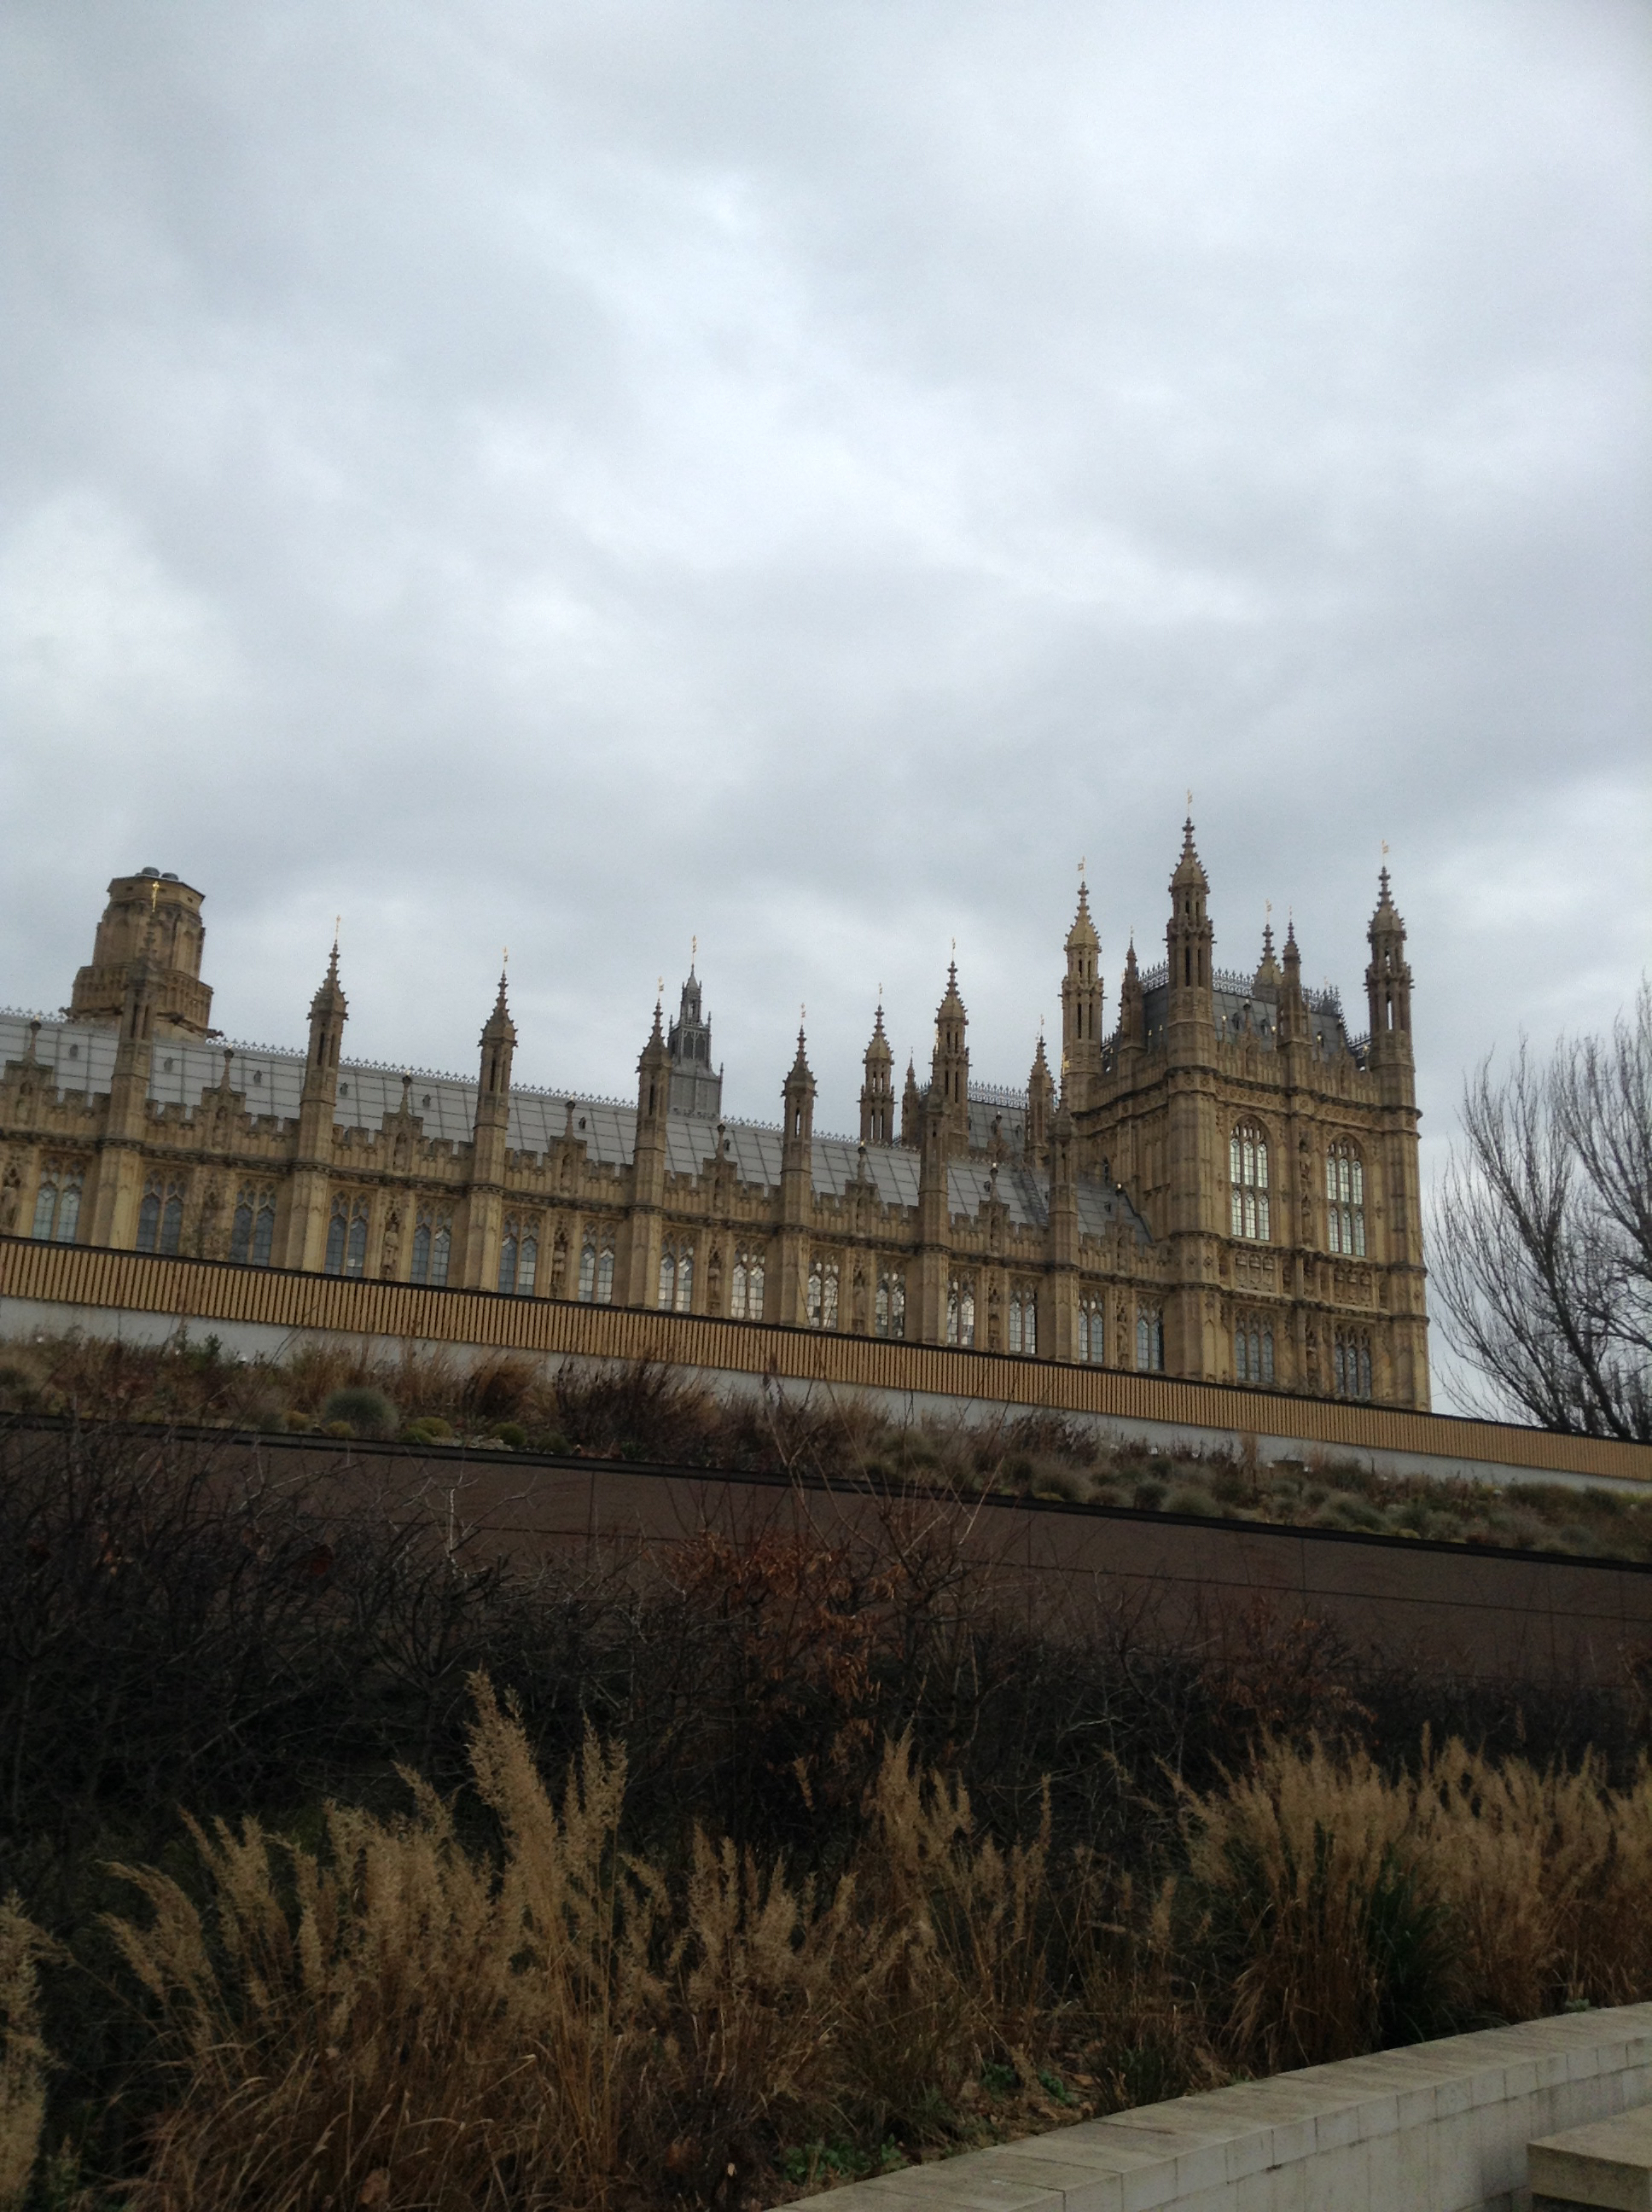

Y3 Egyptians
Our year 3 children enjoyed spending the day being Egyptian.

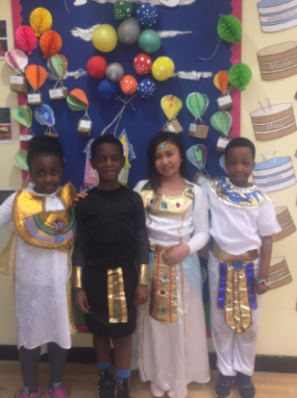

Safer Internet day
All our children were taught this week about keeping safe on the internet. Please reinforce that message.

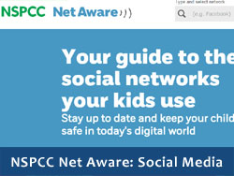

Please read the information on this website. (Y)Our children need to be safe and protected online. This will help you.

Head teacher news.
Mrs Clare Scott will take over after Easter please support her as much as you do me.

Y1 Phonics
Thank you to all the year 1 parents who attended the phonics workshop yesterday. We hope that you took away some useful tips and ideas to use at home. Thank you for your continued support,

30 Y6 trumpeters.



DISCOVERING BRASS – CONCERT INFORMATION FOR PARENTS/CARERS

Date: 8th March 2018
Venue: Duke’s Hall – Royal Academy of Music, Marylebone Road, London, NW1 3HP
_{Concert Start Time: 12.30pm}
Duration: 45 minutes (no interval)
Ticket Price: Free
Ticket Booking: Online via https://discoveringbrass.eventbrite.co.uk (this will go live later this afternoon)
Ticket Limitation: There is no minimum ticket allowance, but available seating is limited so booking as soon as possible is highly recommended

If you would like to attend this special event please let me know or get your own free tickets as shown above.


Our Girls football team
Were terrific in their games against Ripple School drawing 1-1 and winning 5-1

Ofsted report.
Our report is now ready to view on the website. Thankyou everyone for making our school a lovely place!


Nursery
The application forms for children starting Nursery September 2018 are available from the school office. If your child was born between September 2014 and August 2015 and you would like them to attend St Peter’s Nursery, please come in and pick up a pack. Applications need to be submitted by Friday 16th March.

Mon 19th Feb | 8.30  3.15pm-4.30pm | Yr 1 Bible study  Yr 5 Multisports
Tues 20th Feb | 8am  8am  3.15pm – 4.25pm  3.15pm – 4.30pm | Yr 2 Judo  Yr 3 Multisports  Yr 3/4 Football  Yr 4 Multisports
Wed 21st Feb | 8am | Yr 5/6 Boys/Girls Gymnastics
Thurs 22nd Feb | 8am | Yr 5/6 Boys/girls Gymnastics
Fri 23rd Feb | 8am  8am  8am  2.45 pm | Yr 3 Judo  Yr 5/6 Boys Football  Yr 5/6 Girls Football  Whole School Assembly

Happy Birthday 5th February – 18th February 2018

Abdulmuheez Akanmu 9, Ysabel Aromin 9, Ernest Okoli-Ugwunze 8, Joshua Olasehinde 6, Jevanni Campbell 7, Chimelumeze Okafor 6, Michelle Onyekuru 5, Anais Hammond 9, Jethro Martinez 5, Levi Ndah 5, Dumebi Okafor 8, Clinton Onyekuru 7, Aimuamwosa Egharevba-Samuel 7, Lasandra Sarpong 11, Obi Anyanwu 8, Isabella Shoring 11.

Drivers.
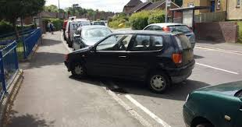
Please be considerate about where you park as our school is in a residential area where other people live and work.

Children travelling home alone.
Ideally these will only be Y6 children. In every case parents must speak to me and put in writing their reasons. We want to develop the independence of our children but every case is different.


Breakfast Club
7.30am – 8.45am (last entrance at 8.30am) £2.00 per session paid in advance via parentpay.

Please make sure a responsible adult drops your children off at breakfast club and not an older sibling from the school who will then either go home or out to an adult waiting in the car. Once your child is on school premises they are expected to stay. Food is provided please do not send children in with food from shops or home.

Newsletter/website.
Firstly thank you to those of you who read this every week. We put it on the website and email it out to the emails we have for you.
The website can also be seen through a free app –Schudio School App then put in the postcode and all of it is on your phone for free.

Blog
A new addition to our website under the parents section informing you of what your child/children have been learning this week. Please take a look.

Please see some photos of school life on our twitter link: @stpetersdagenham

Chaplaincy Newsletter
This is a new monthly newsletter that can be found on our website. Please take a look at this month’s edition

Attendance
If your child is not coming into school, please call the school office by 10am on the first day they are absent and let us know the reason.

Contact Information
Please make sure you keep us updated in any changes to addresses, emails and telephone numbers.

Parent Pay
Your child will no longer receive a hot dinner if their account is not at least £2.10 in credit. An emergency meal could be given at Mr Craft’s discretion if you contact the Office before 9.30am. It is your responsibility to make sure your child’s parent pay is in credit at all times.

Party Bags
We love to celebrate a birthday at St Peter’s. We just ask that any birthday cake is pre-cut and wrapped individually and party bags are not too heavy as they must be brought in with the child first thing in the morning. THEY WILL NOT BE ACCEPTED IN THE OFFICE.

Mr John Riordan.R.I.P
My father in law, who many of you will have known, passed away peacefully this morning. I have spent quite a bit of this week with my family and your prayers are so needed and appreciated. Thankyou

Yours sincerely

Mr D Craft Headteacher

SCHOOL CLOSES AT 3.15PM ON FRIDAY 9TH FEBRUARY AND RE-OPENS ON MONDAY 19TH FEBRUARY 2018

